**A Report**

**On**

**VBE&A ASSIGNMENT-4**

**Ansys analysis of 2D car.**

SUBMITTED TO: -

**DR AJAY KUMAR SOOD**

**DR SUSHIL CHANDRA**

**Submitted By**

**Name of the Student**                                                      **Enrolment Number**

GUNDA VENKATA SAI JAI HARSHA                                190C2050003

SRIRAMMOJU SAI PRIYATHAM 190C2050016

TUMMALA VISHAL REDDY 190C2050012

MUKUL DEV SAINI 190C2050007

T VAMSHIDAR REDDY 190C20500013



SCHOOL OF ENGINEERING AND TECHNOLOGY

BML MUNJAL UNIVERSITY GURGAON

**Abstract**

In this project, we are making 2D car modelling for the Ansys analysis on 2D car. First, we will be making the 2d geometry and then go for the meshing part and apply all the conditions which are required and final we will get the results of velocity ,Residuals, contours , streamlines of the 2d car model.

**Introduction**

First we will be modelling the 2d car and create all the things which are required for the analysis.

Geometry of 2d car

All Dimensions are in meters. 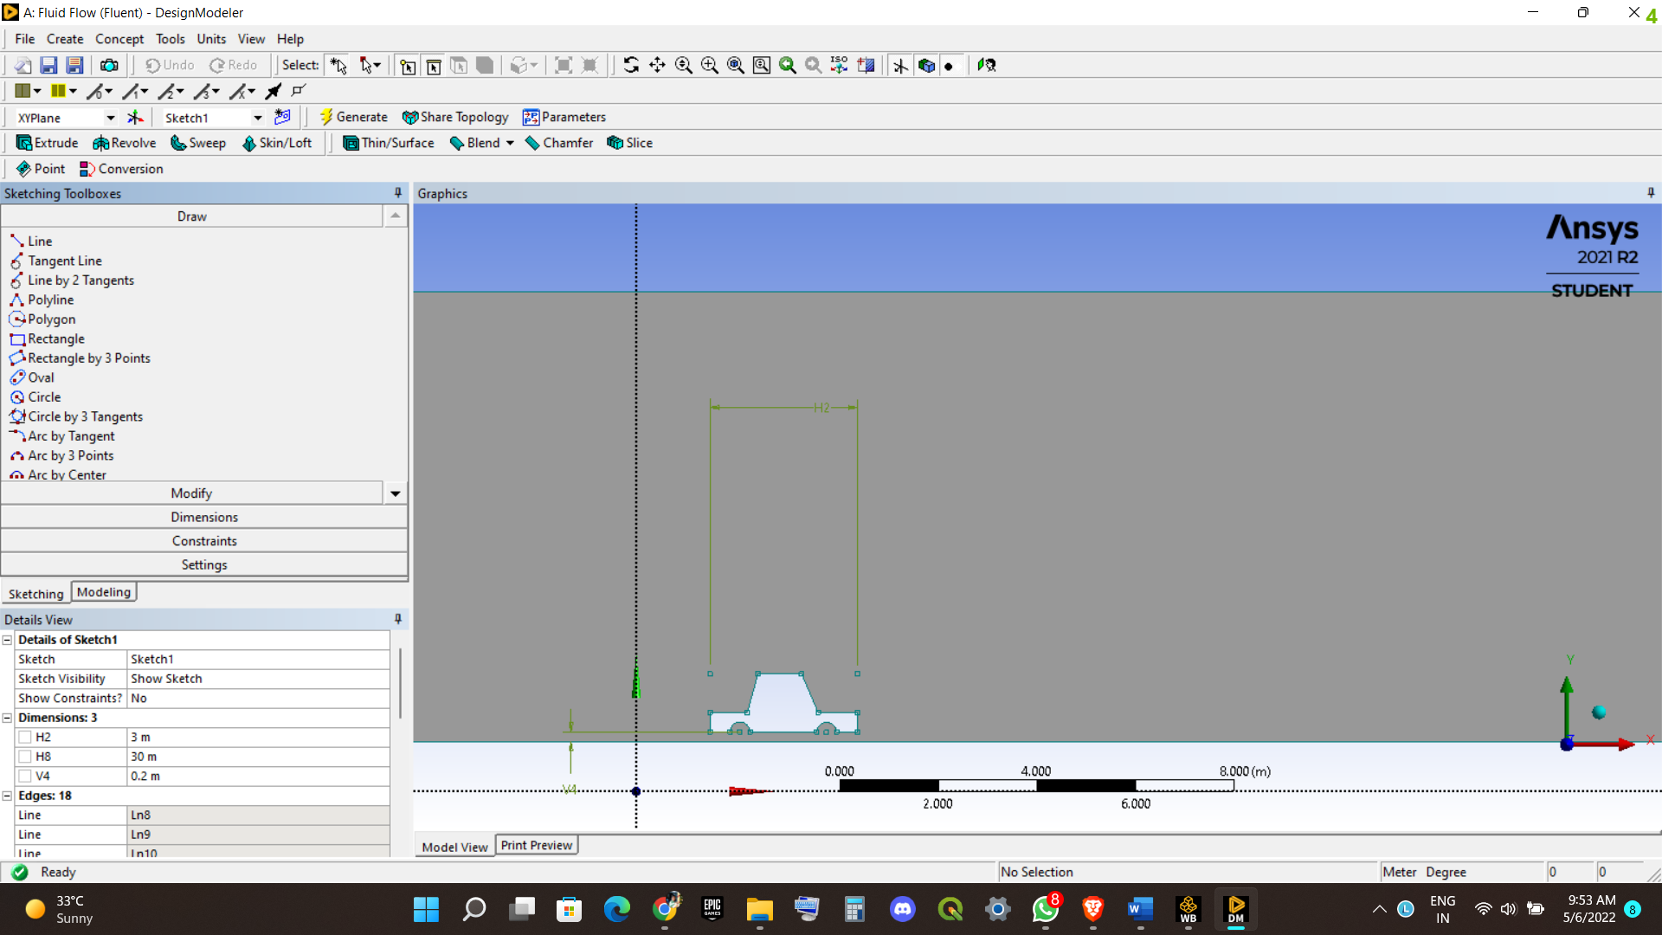

Car model

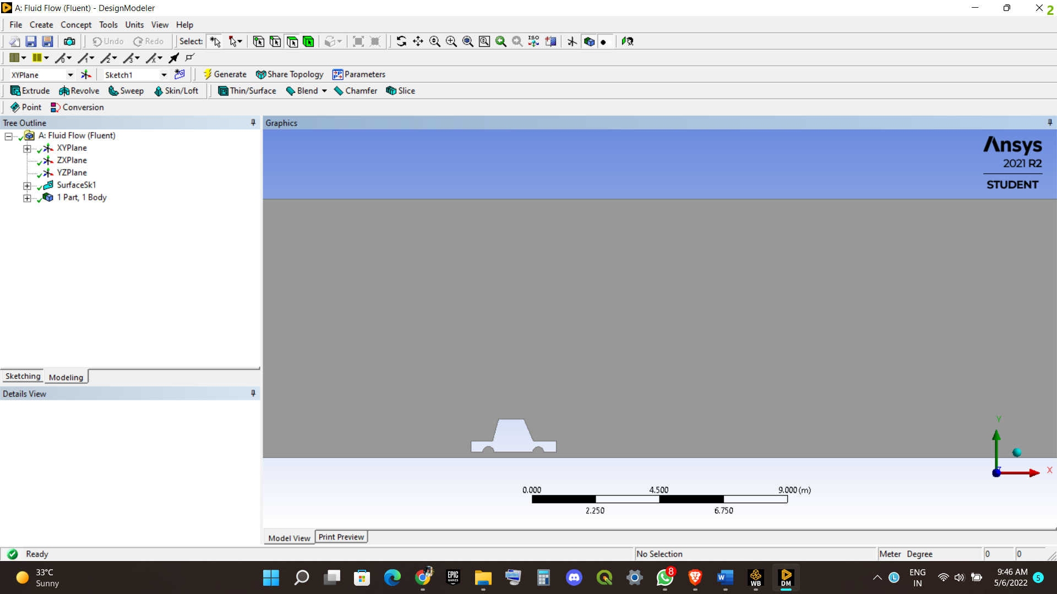

Dimensions of all.

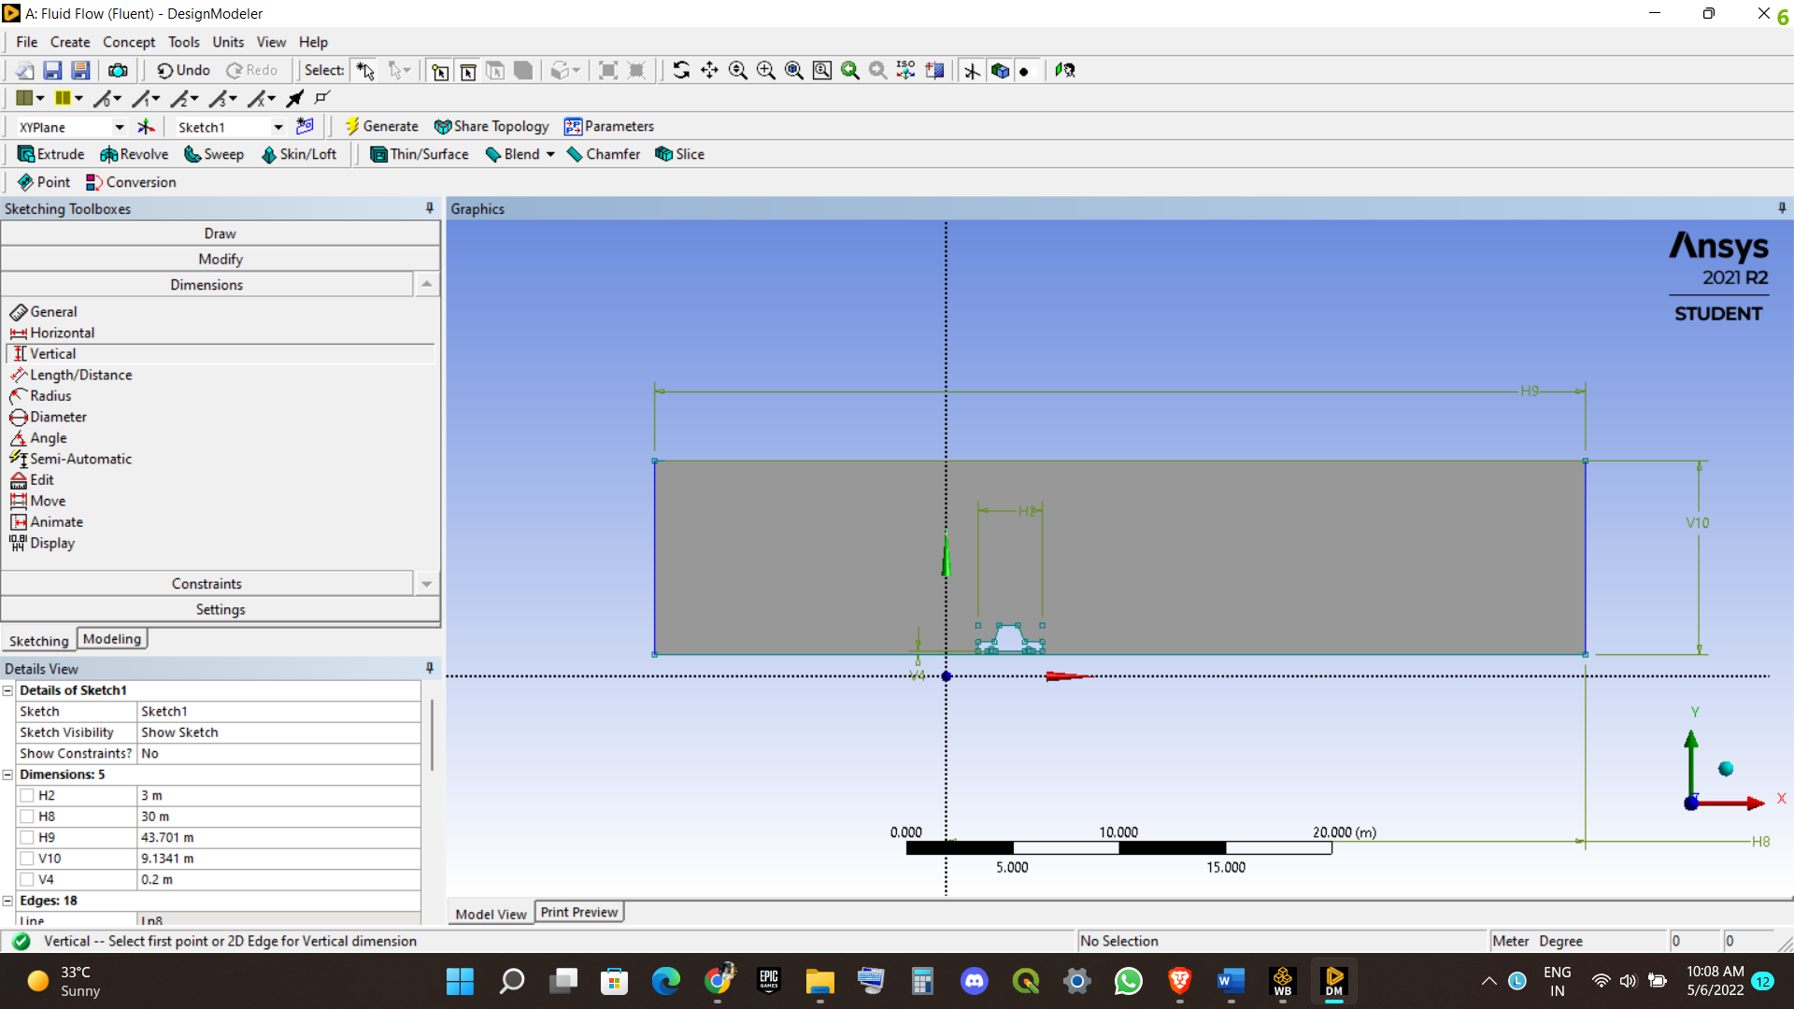

Next we will be doin the meshing

We would apply CFD as Physics prefernce.

And the solver Prefernce is fluent.

I have used edge size meshing and element size 100cm and growth rate 1.05

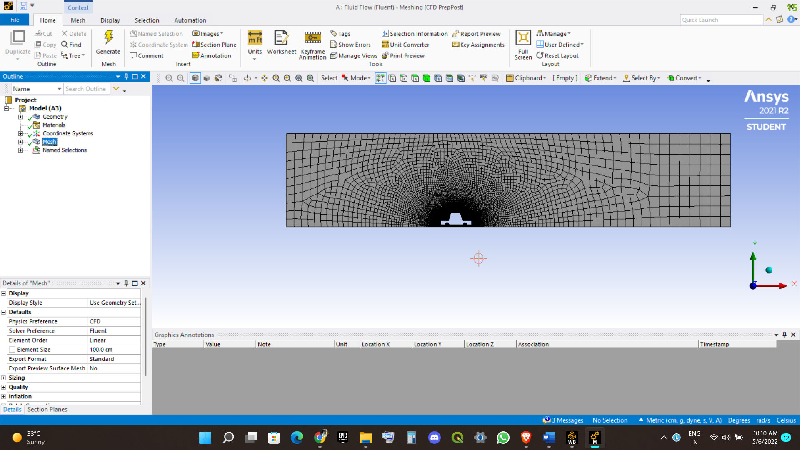

Named slections

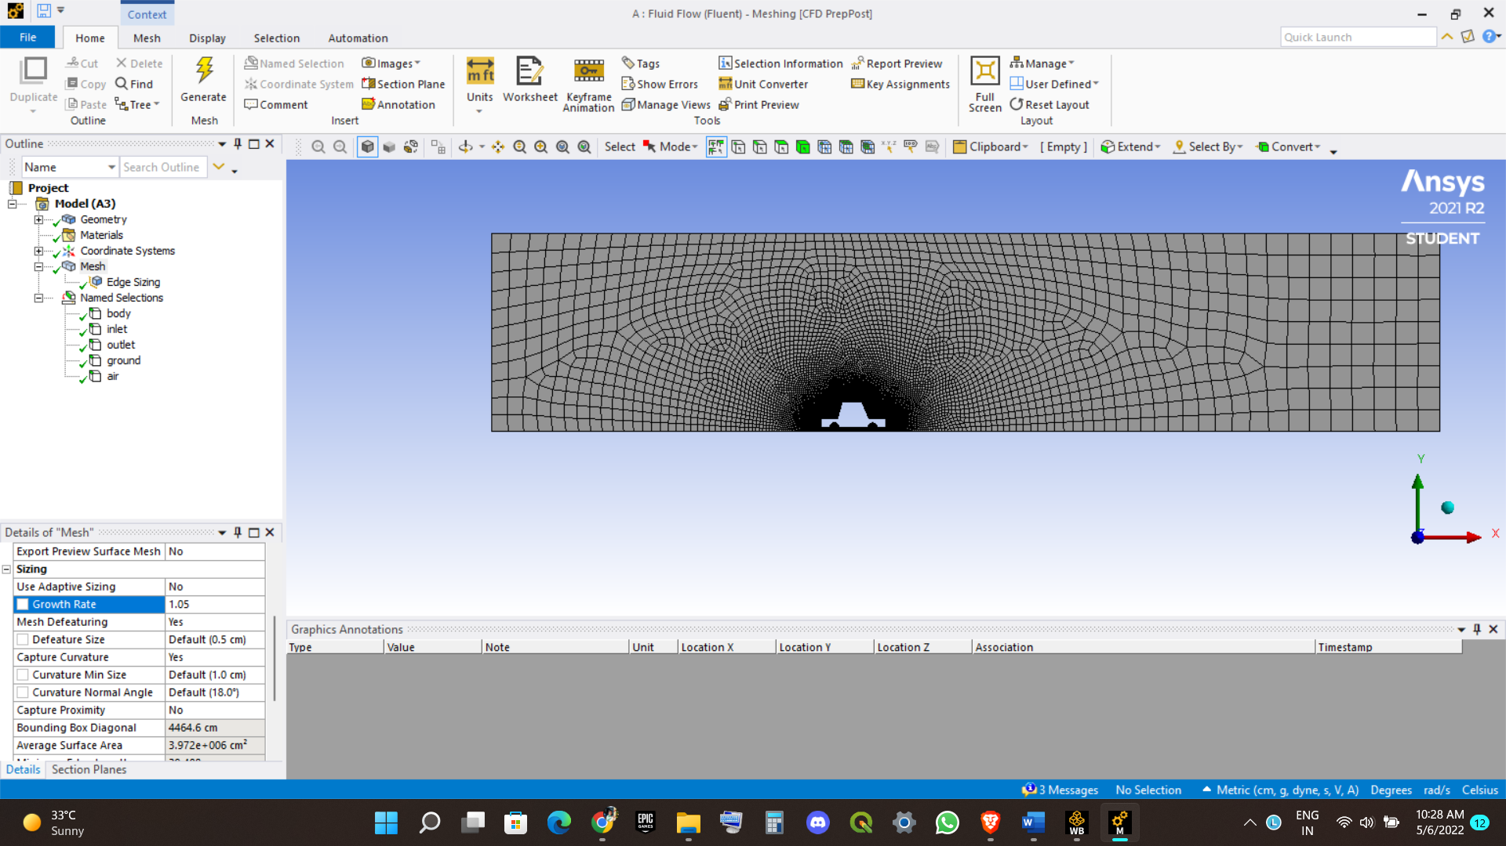

Next fluent analysis starts

First we will be apply the viscous model and apply k omega.

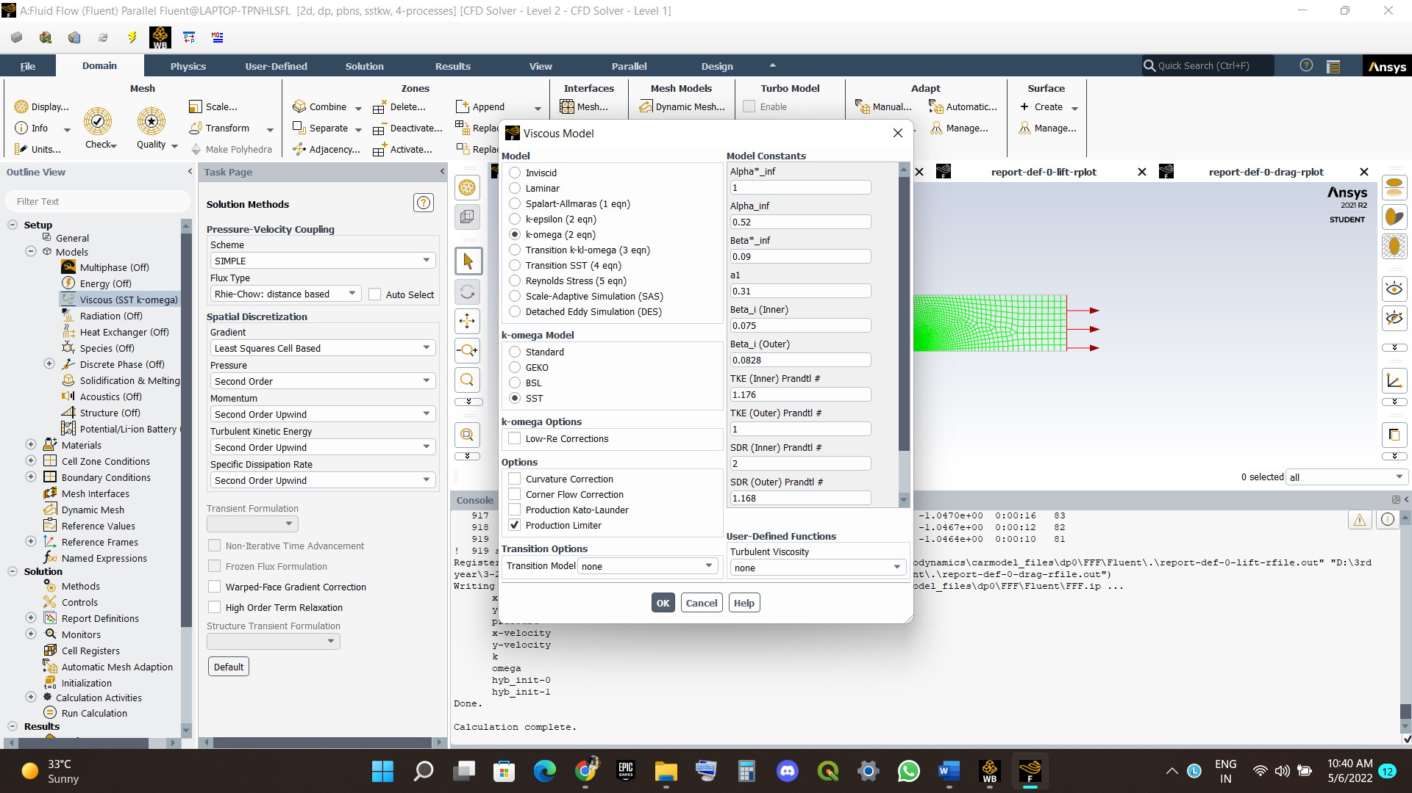

Check the materials

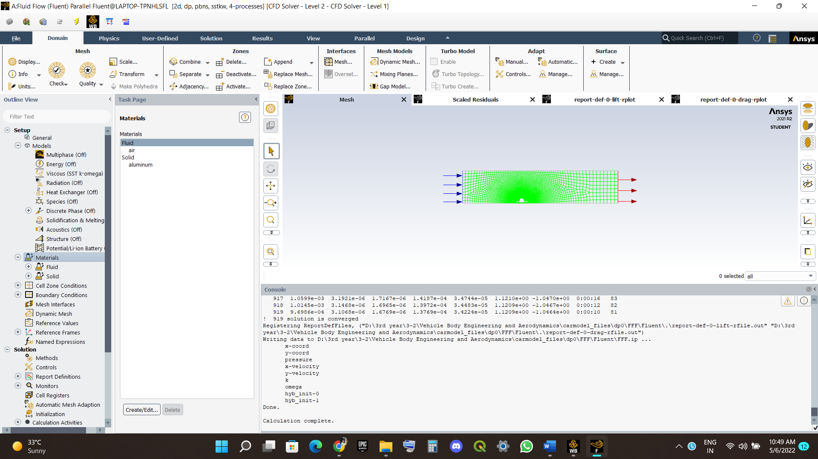

Next inlet 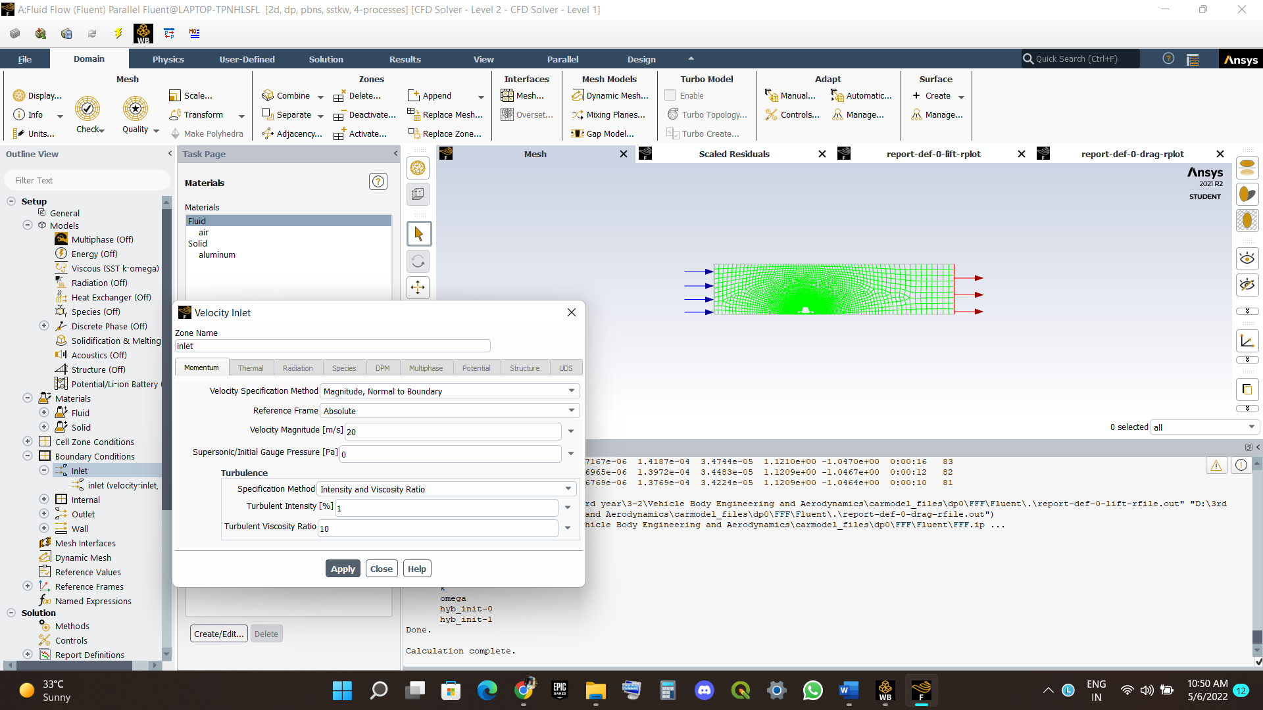Velocity of 20m/s

Turbluent Intensity = 1%

Refernence values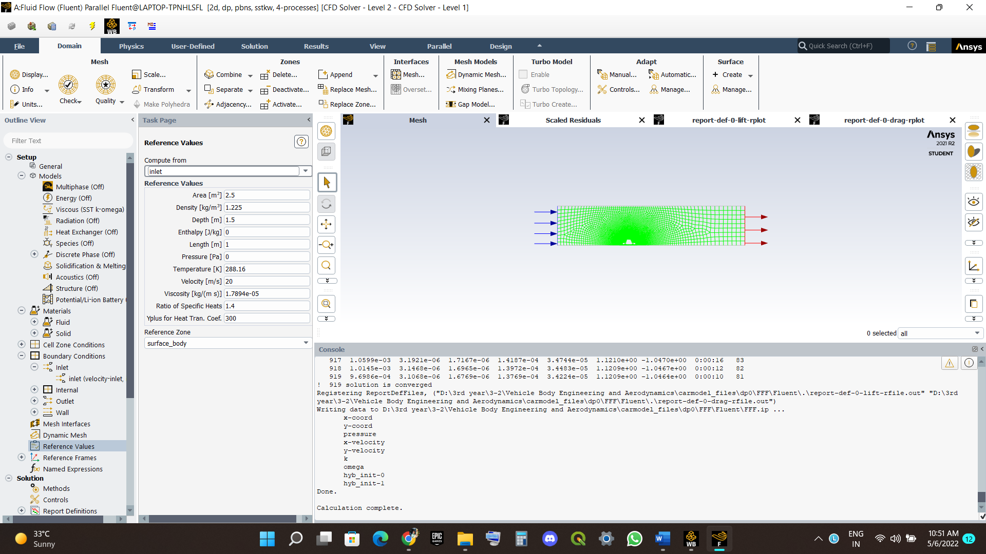

Area = 2.5m^2

Remaining all same

Refernce zone = Surface Body

**Next solution Methods**

We will use simple method and the gradient as least squares cell based.

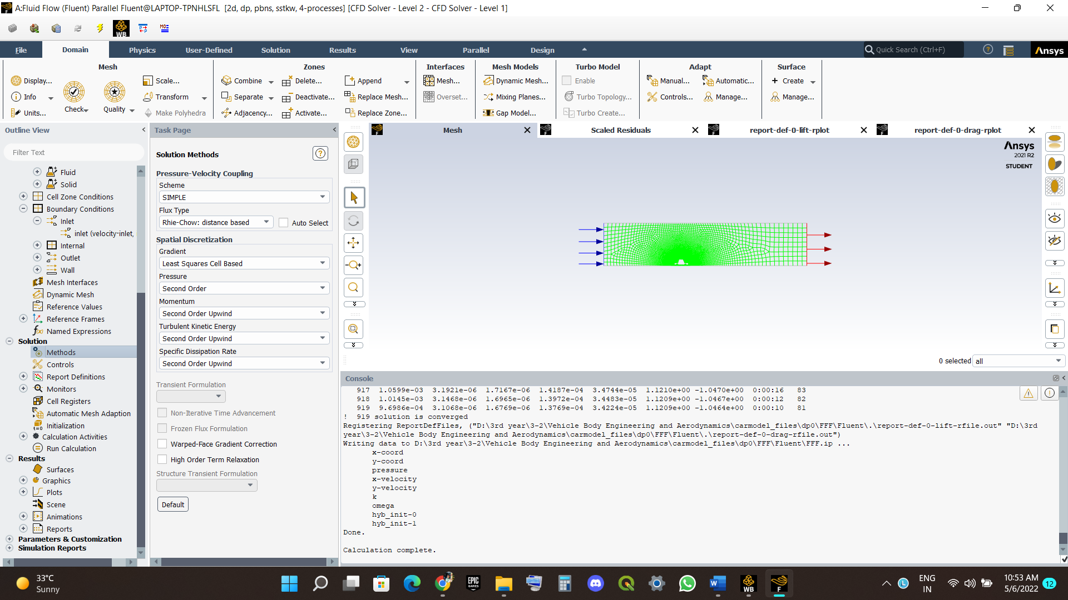

**Report definitions**

we will be adding the drag and lift 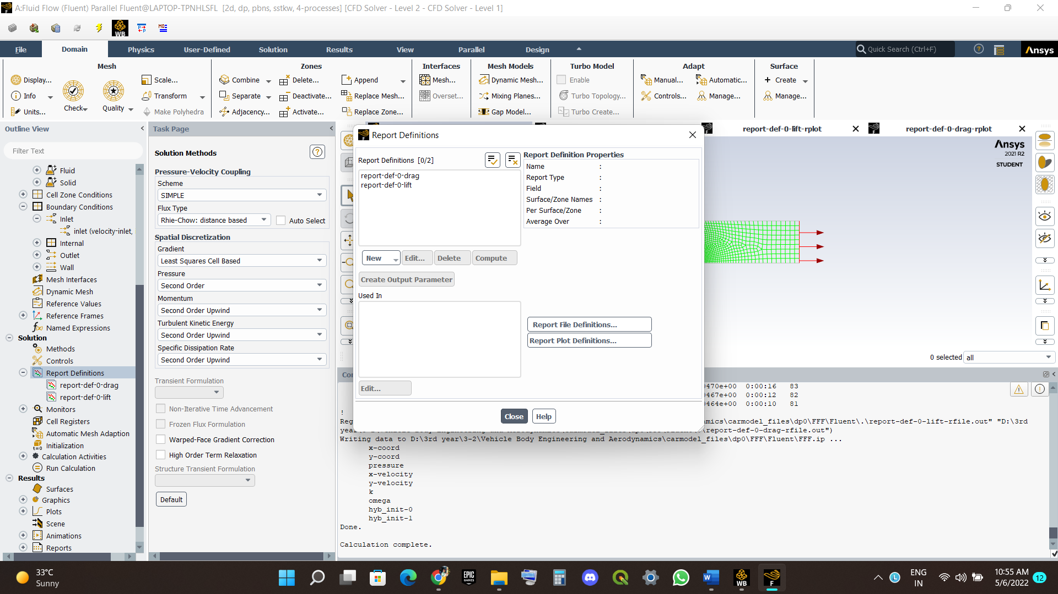

Solution Intialization

We will use hybrid intilization And we get points.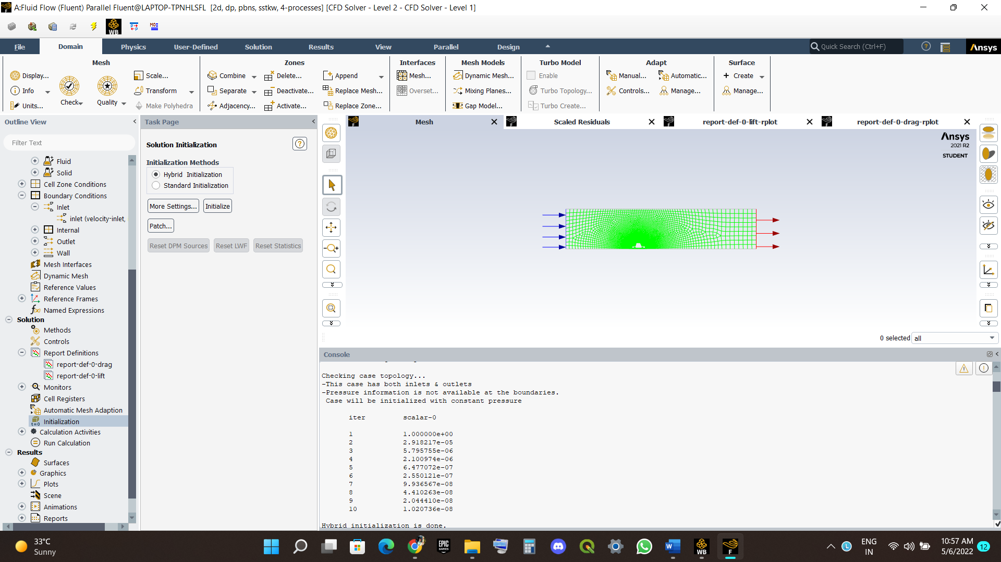

At last we will run calculations with 1000 iterations.

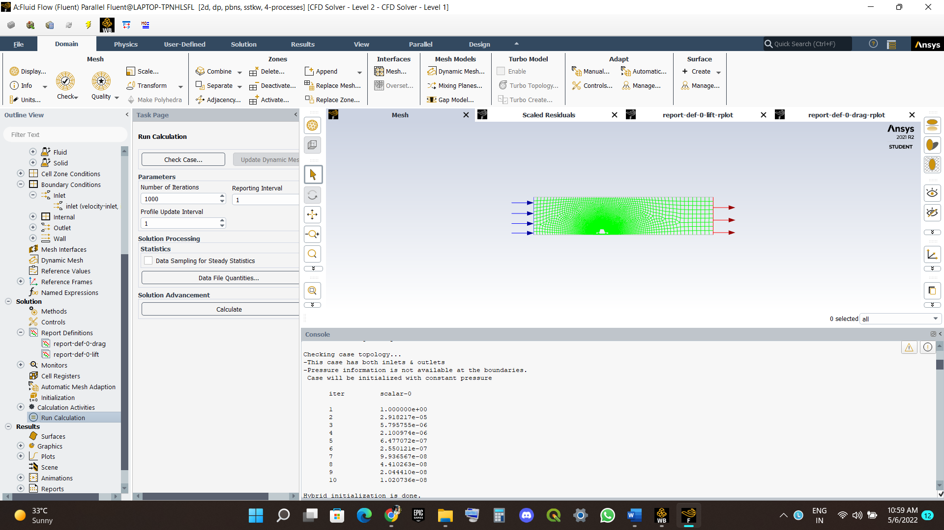

Results

**Scaled residuals**

**Graph**

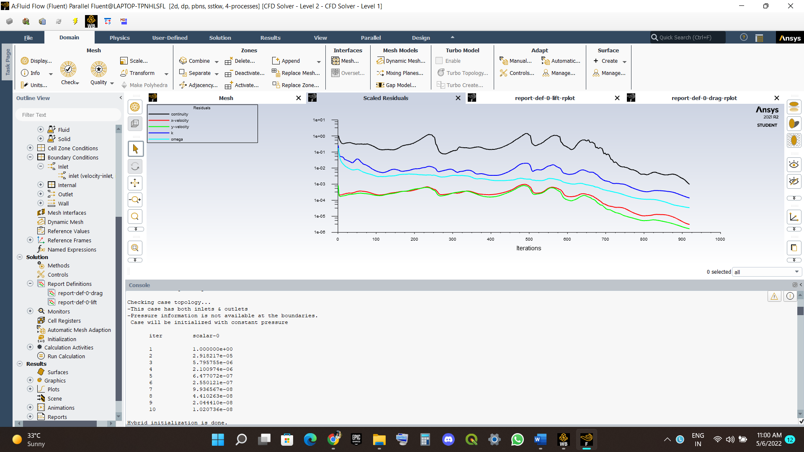

Report of lift graph.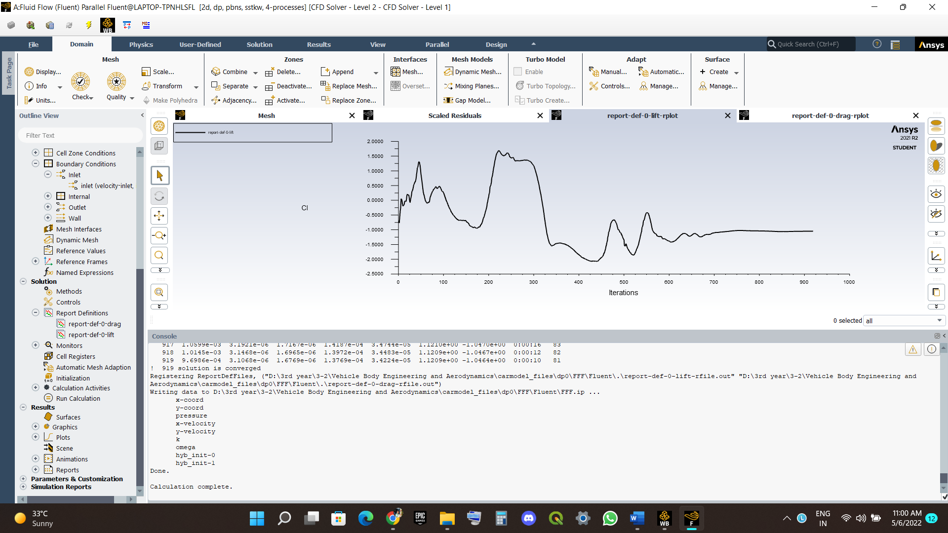 Report of drag graph.

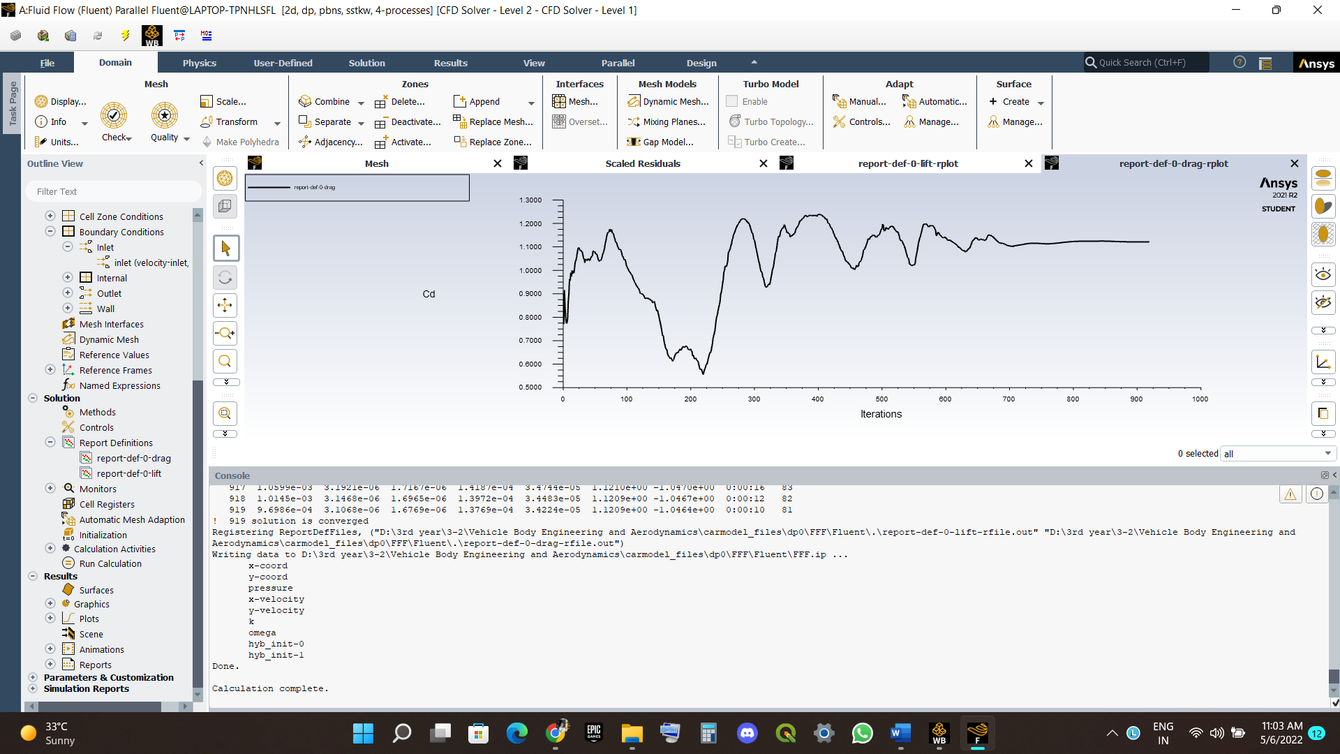

Velocity

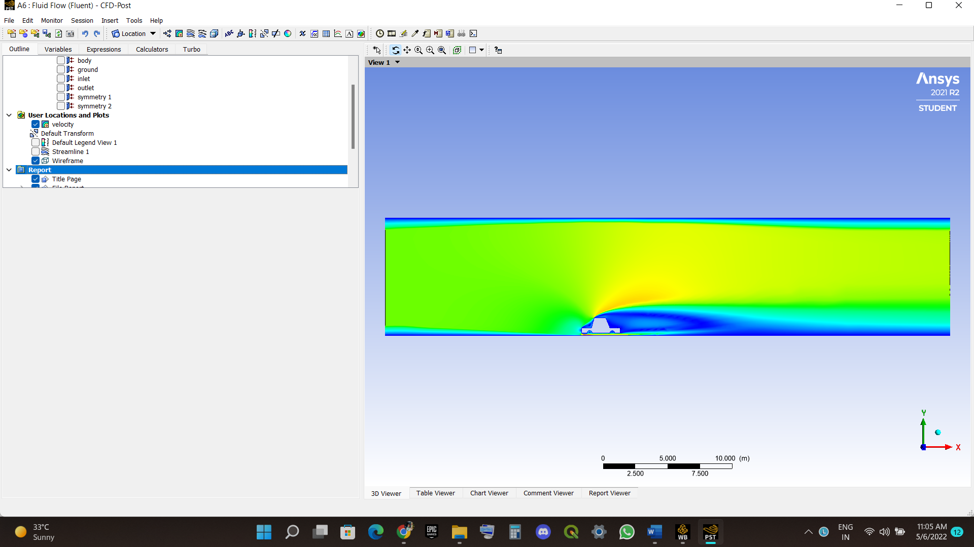

Stream line

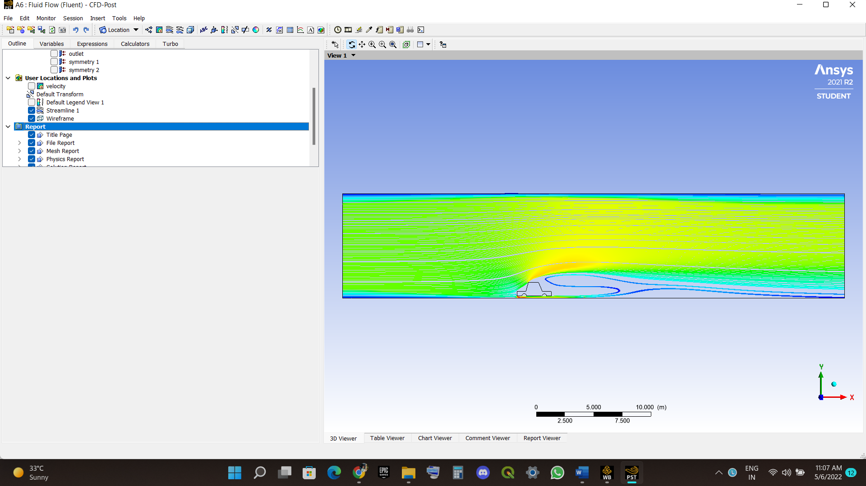

ANSYS Report

ANSYS Logo: AnsysReportLogo.png

Date: 2022/05/06 11:10:17

______________________________________________________________________

Contents

1. File Report

Table 1 File Information for FFF

2. Mesh Report

Table 2 Mesh Information for FFF

3. Physics Report

Table 3 Domain Physics for FFF

Table 4 Boundary Physics for FFF

4. User Data

Figure 1

______________________________________________________________________

1. File Report

Table 1. File Information for FFF

Case FFF

File Path D:\3rd year\3-2\Vehicle Body Engineering and Aerodynamics\carmodel_files\dp0\FFF\Fluent\FFF-1-00919.dat.h5

File Date 06 May 2022

File Time 11:04:15 AM

File Type CFF

File Version --

2. Mesh Report

Table 2. Mesh Information for FFF

Domain Nodes Elements

surface_body 59464 28978

3. Physics Report

Table 3. Domain Physics for FFF

Domain - surface_body

Type FLUID

Location surface_body

Table 4. Boundary Physics for FFF

Domain Boundaries

surface_body Boundary - air

Type WALL

Location air

Boundary - body

Type WALL

Location body

Boundary - ground

Type WALL

Location ground

Boundary - inlet

Type VELOCITY-INLET

Location inlet

Boundary - outlet

Type PRESSURE-OUTLET

Location outlet

Boundary - symmetry 1

Type SYMMETRY

Boundary - symmetry 2

Type SYMMETRY

4. User Data

Figure 1 - Report/Figure001.png | Report/Figure001.avz

Conclusion

In this project I have learned about the design and analysis of the 2d car and designing and analysis by fluent of the car make the project more interesting and we have validated the things like velocity , streamlines , Lift report , drag report, scaled residuals these make me learn more about the analysis of car and thank you sir for providing these type of projects makes more experiential learning and make us more Enthusiastic and Thank you for sirs.

THANK YOU SIR